MARIAN LIEBOWITZ ARTIST MANAGEMENT
www.marianliebowitz.com marian@marianliebowitz.com 619.988.0751

OUTREACH
PROGRAMS
Endorsed as cultural ambassadors by both the United States Consulate and the Mexican Consulate, Jarabe Mexicano strives to create a deeper and more inclusive sense of family and community through their strong commitment to provide a variety of educational and community outreach programs, which include:
,._.._ . I --
\r' I " • 'i•-'
- I'.=---- -I 1-

Concerts for schools and retirement homes that promote audience participation through call & response, clapping to syncopated patterns, and learning about the history of the musjc and instruments the band plays.
Collaborative performance opportunities with local ballet folkl6rico groups with a focus on Son Jarocho and Norteiio styles, especially apt for Cinco de Mayo and Hispanic Heritage Month celebrations.

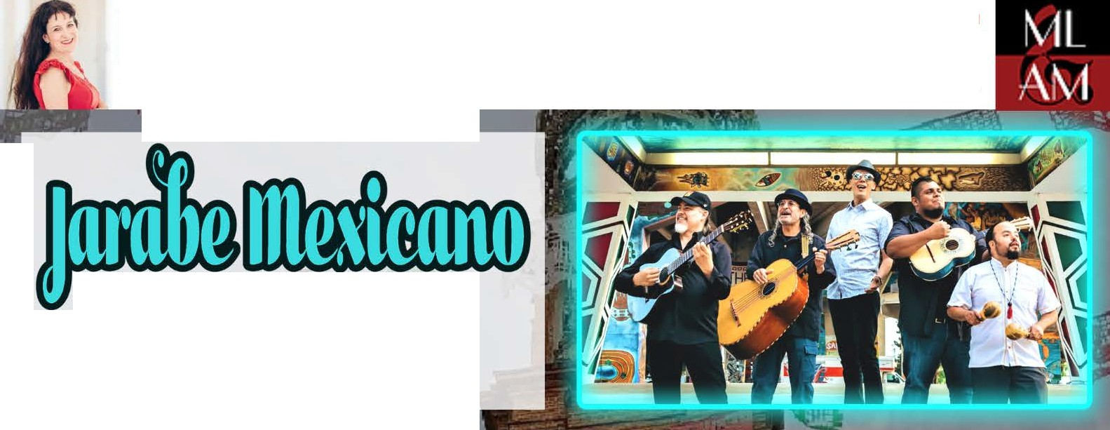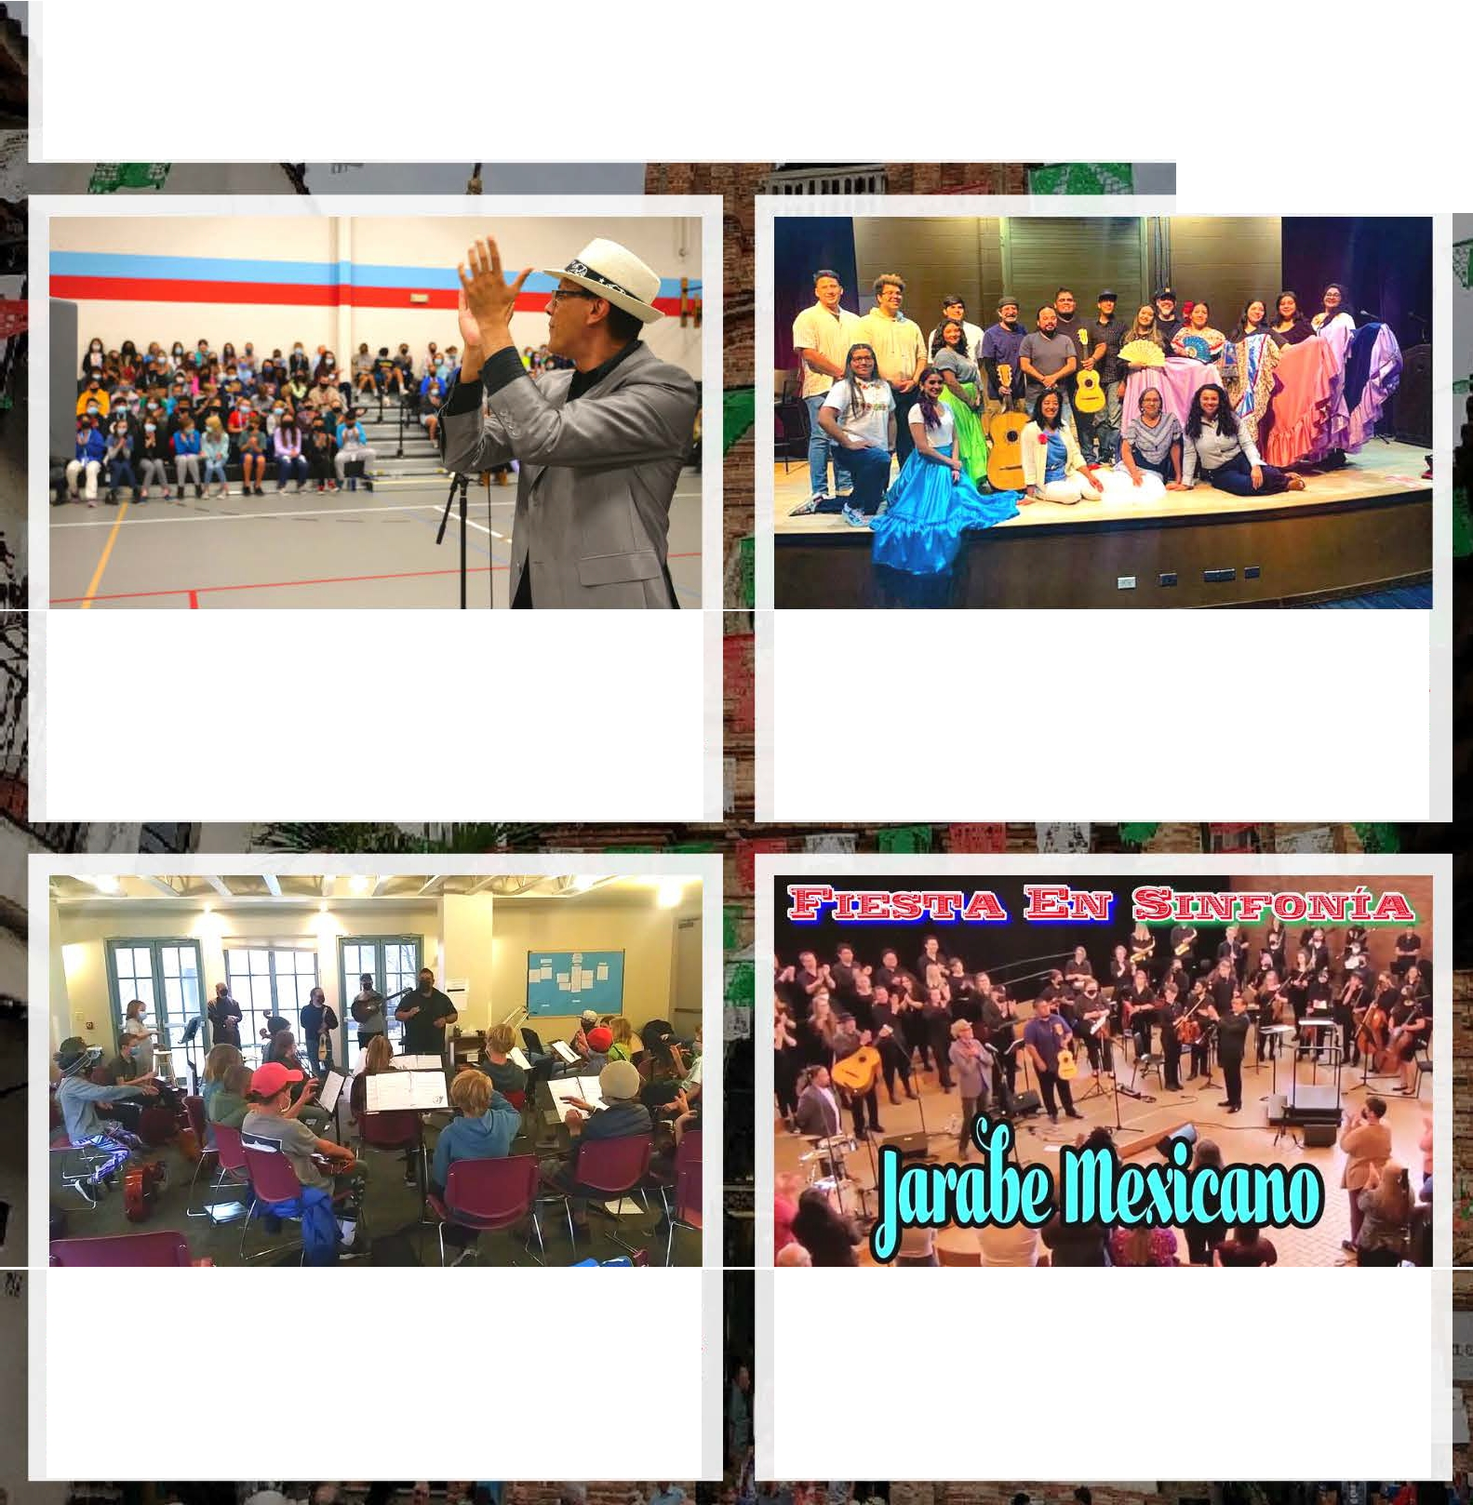Musical collaborations with intermediate and advanced student ensembles that include workshops on performance technique and professional development as well as masterclasses for voice students.
A full collaborative program for university ensembles called "Fiesta En Sinfonia," which features orchestral arrangements of musical styles Jarabe offers such as Huapango, Cumbia, Bolero, and Ranchera.

